STUDENT ATTENDANCE MANAGEMENT SYSTEM

Submitted by

Vignesh M(RA2111047010205)
Midhun C(RA2111047010204)

Under the Guidance of

Dr. SUMATHY G

Assistant Professor, Department of Computational Intelligence

In partial satisfaction of the requirements for the degree of

BACHELORS OF TECHNOLOGY
in
COMPUTER SCIENCE ENGINEERING

with specialization in Artificial Intelligence


SCHOOL OF COMPUTING
COLLEGE OF ENGINEERING AND TECHNOLOGY
SRM INSTITUTE OF SCIENCE AND TECHNOLOGY
KATTANKULATHUR - 603203
April 2023

SRM INSTITUTION OF SCIENCE AND TECHNOLOGY
KATTANKULATHUR-603203

BONAFIDE CERTIFICATE

Certified that this Course Project Report titled “STUDENT ATTENDANCE MANAGEMENT SYSTEM” is the bonafide work done by Vignesh M(RA2111047010205) , Midhun C(RA2111047010204) of II Year/ IV Sem B.Tech (AI) who carried out under my supervision for the course 18AIC207J - Database Management Systems for Artificial Intelligence. Certified further, that to the best of my knowledge the work reported herein does not form part of any other work.

SIGNATURE  Faculty In-Charge  Dr.Sumathy G  Assistant Professor  Department of Computational Intelligence  SRM Institute of Science and Technology  Kattankulathur Campus, Chennai | HEAD OF THE DEPARTMENT  Dr. R Annie Uthra  Professor and Head ,  Department of Computational Intelligence,  SRM Institute of Science and Technology  Kattankulathur Campus, Chennai

ABSTRACT

Hospital Management System is an organized computerized system designed and
programmed to deal with day-to-day operations and management of hospital
activities. The program can look after inpatients, outpatients, records, database
treatments, status illness, billings in the pharmacy, and labs. It also maintains hospital
information such as ward id, doctors in charge, and department administering. The
major problem for the patient nowadays is to get the report after consultation, many
hospitals manage reports in their system but it's not available to the patient when
he/she is outside. In this project, we are going to provide the extra facility to store the
report in the database and make it available from anywhere in the world.The project
Hospital Management system includes registration of patients, storing their details
into the system, and also computerized billing in the pharmacy, and labs. The software
has the facility to give a unique id for every patient and stores the details of every
patient and the staff automatically. It includes a search facility to know the current
status of each room. Users can search the availability of a doctor and the details of a
patient using the id. The Hospital Management System can be entered using a
username and password. It is accessible either by an administrator or receptionist.
Only they can add data into the database. The data can be retrieved easily. The
interface is very user-friendly. The data are well protected for personal use and make
the data processing very fast. The Hospital Management System is powerful, flexible,
and easy to use and is designed and developed to deliver real conceivable benefits to
hospitals. Hospital Management System is designed for multispeciality hospitals, to
cover a wide range of hospital administration and management processes. It is an
integrated end-to-end Hospital Management System that provides relevant
information across the hospital to support effective decision-making for patient care,
hospital administration, and critical financial accounting, in a seamless flow. Hospital
Management System is a software product suite designed to improve the quality and
management of hospital management in the areas of clinical process analysis and
activity-based costing. Hospital Management System enables you to develop your
organization and improve its effectiveness and quality of work. Managing the key
processes efficiently is critical to the success of the hospital and helps you manage
your processes.

TABLE OF CONTENTS

Chapter No. Title PageNo.

 | 1 INTRODUCTION |  | 1
 | 1.1 Introduction |  | 2
 | 1.2 Problem statement |  | 3
 | 1.3 Objectives  1.4 Scope and applications  1.5 General and Unique Services in the database application  1.6 Software Requirements Specification |  | 4
 | 2 LITERATURESURVEY |  | 5
 | 2.1 Existing system |  | 5
 | 2.2 Comparison of Existing vsProposed system |  | 10
 | 3 SYSTEM ARCHITECTURE ANDDESIGN |  | 15
 | 3.1 Architecture Diagram |  | 15
 | 3.1.1 Front end (UI)design |  | 16
 | 3.1.2 Back end (Database Table) design |  | 17
 | 3.2 ER Diagram and Use case Diagram |  | 18
 | Modules and Functionalities  4 |  | 21
 | 4.1 Subtitle 1 |  | 21
 | 4.1.1 Subsection1 |  | 23
 | 4.1.2 Subsection2 |  | 25
 | 4.2 Connectivity used for database access |  | 28
 | CODING AND TESTING  5 |  | 30
 | RESULTS AND DISCUSSIONS  6 |  | 40
 | 6.1 Subtitle 1 |  | 41
 | 6.2 Subtitle 2 |  | 43
7 |  | CONCLUSION AND FUTURE ENHANCEMENT | 45
 |  | REFERENCES | 46
 |  | LIST OF FIGURES

FigureNo. Figure Name PageNo.

Sample lesions fromeachclass 13

File structureofdataset 13

Diagnosis TechniquesPlot 15

Number of data points ofeachclass 16

OverallArchitectureDiagram 32

Difference between UI&UX 33

IonicFramework 34

LIST OF TABLES

TableNo. TableName PageNo.

2.1 Thresholding segmentationinput | .. | 4
2.2 Computer Vision Pipeline |  | 5

ROC curve CNNanddermatologists 8

Confusion matrix with CNNvsdoctors 10

ABBREVIATIONS

AES Advanced EncryptionStandard
ANN Artificial NeuralNetwork

CSS Cascading StyleSheet
CV ComputerVision
DB DataBase
DNA DeoxyriboNeucleicAcid
SQL Structured QueryLanguage
SVM Support VectorMachine
UI UserInterface

2) BACKGROUND

A Hospital Database Management System (HDMS) is a computer or web based system that facilities managing the functioning of a hospital or any medical set up. This system will help in making the whole functioning paperless.
The hospital database includes all the necessary patient data. The disease history, test results, prescribed treatment can be accessed by doctors without much delay in order to make an accurate diagnosis and monitor the patient's health. It enables lower risks of mistakes.
A hospital is a place where Patients come up for general diseases. Hospitals Provide facilities like:

- Consultation by Doctors on Diseases.
- Diagnosis for diseases.
- Providing treatment facility.
- Facility for admitting Patients (providing beds, nursing, medicines etc.)
- Immunization for Patients/Children.
Various operational works that are done in a Hospital are:

- Recording information about the Patients that come.
- Generating bills.
- Recording information related to diagnosis given to Patients.
- Keeping record of the Immunization provided to Children/Patients.
- Keeping information about various diseases and medicines available to cure them.
These are the various jobs that need to be done in a Hospital by the operational staff and Doctors. All these works are done on papers.
The work is done as follows:
- Information about Patients is done by just writing the Patients name, age, and gender. Whenever the Patient comes up his information is stored freshly.
- Bills are generated by recording price for each facility provided to Patient on a separate sheet and at last they all are summed up.
- Diagnosis information to patients is generally recorded on the document, which contains Patients information. It is destroyed after some time period to decrease the paper load in the office.
- Immunization records of the children are maintained in pre-formatted sheets, which are kept in a file.
- Information about various diseases is not kept as any document. Doctors themselves do this job by remembering various medicines
All this work is done manually by the receptionist and other operational staff and lot of papers are needed to be handled and taken care of. Doctors have to remember various medicines available for diagnosis and sometimes miss better alternatives as they can’t remember them at that time.

MODULE DESCRIPTION

Project mainly consists of 3 modules, which are:

- Admin module

- User module (patient)

- Doctor module

Admin module:

- manage department of hospitals, user, doctor, nurse, pharmacist, laboratorist

- watch appointment of doctors

- watch transaction reports of patient payment

User module (patient):

- View appointment list and status with doctors

- View prescription details

- View medication from doctor

Doctor module:

- Manage patients. account opening and updating

- Create, manage appointment with patient

- Create prescription for patient Provide medication for patients

Use case diagram with explanation

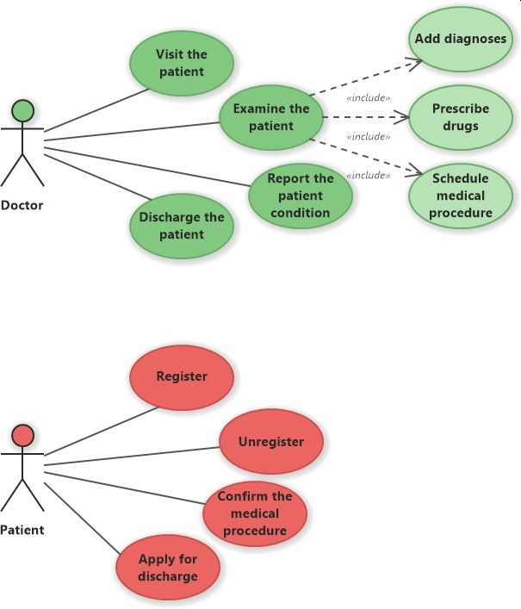

This Use Case Diagram is a graphic depiction of the interactions among the elements of the Hospital Management System. It represents the methodology used in system analysis to identify, clarify, and organize system requirements of Hospital Management System

Class diagram with explanation

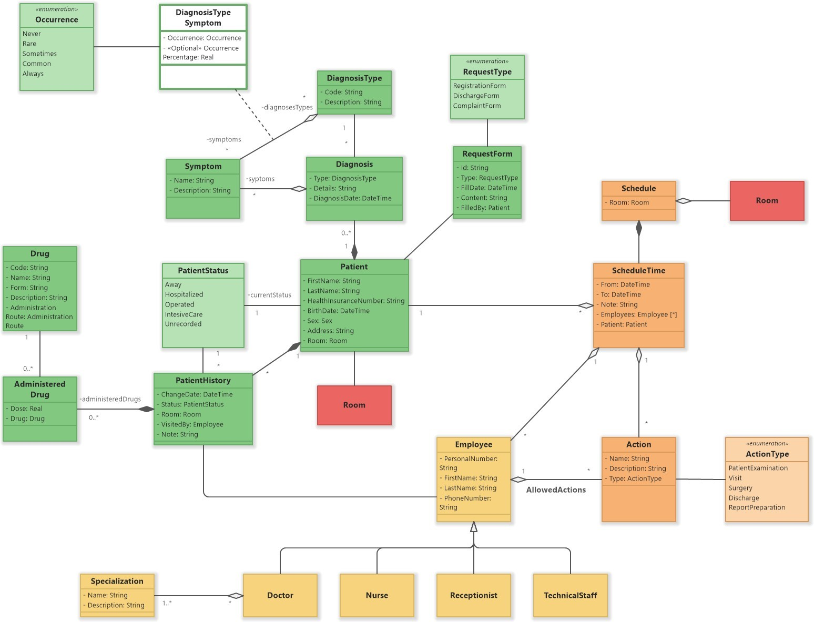
Diagram for Hospital Management Systems. It is also denoted by the Hospital domain Model Diagram. The Domain Model for Hospital Management System is depicted by multiple class diagrams.The diagram gives you a brief idea about the Hospital management process that has small but important substructures such as staff structure, hospital structure, patient treatment terminology, and relationship with patients.The class diagram depicts the classes, an association class, and enumerations that are used within the modeled hospital Sequence diagram with explanation

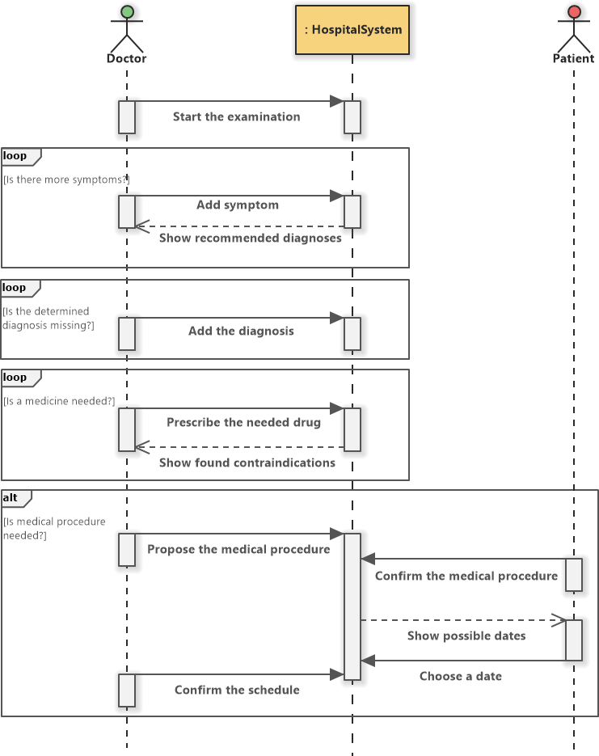
It is a UML diagram that depicts the sequence of events that should occur in a hospital management system. This graphic provides insight and guidance to programmers and developers on how to construct the system. The notion described in a sequence diagram will speed up the construction of a Hospital Management system.The developed sequence diagram depicts the sequence of events in Hospital Management. The actors are represented by a stick figure, whereas the transactions or classes are represented by objects in this example. It will provide you with a detailed description of how the Hospital Management System behaves.

Communication diagram with explanation
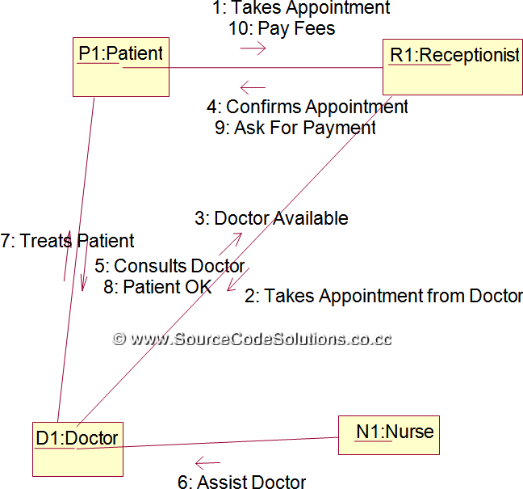
Communication diagram is another form of interaction diagram. It represents the structural organization of a system and the messages sent/received. Structural organization consists of objects and links.The purpose of a communication diagram is similar to a sequence diagram. But the specific purpose of a communication diagram is to visualize the organization of objects and their interaction

Deployment diagram with explanation

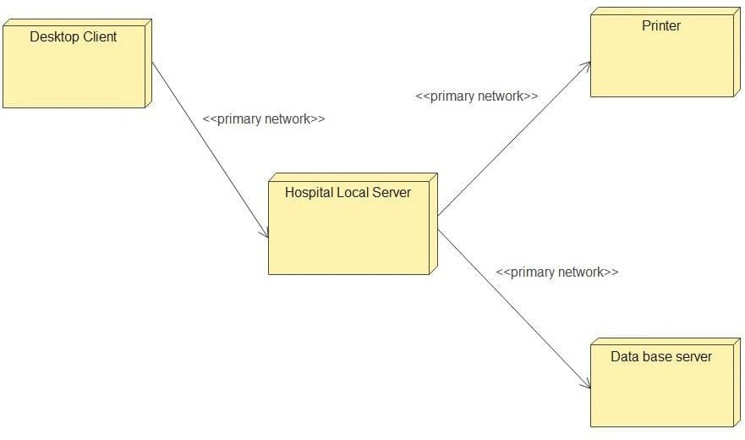
Deployment diagram for hospital systems is able to define how the software and hardware work and where the processing takes place. The needed hardware and software specifications of the hospital system are visualized using deployment diagrams. It is one of the structural diagrams which describes the physical aspects of a real-world project.

IR DIAGRAM:

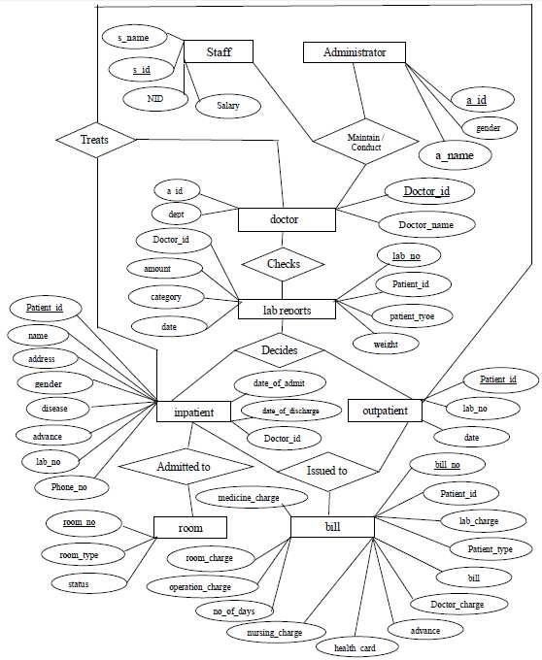

The proposed ER diagram for Hospital DBMS with relationship shows the entity of the proposed Hospital Management system database, which is presented by tables; the tables are made to meet the required specification of the system and provide much more specific details of each entity within the system.
Data Tables:
- Administrator Table:
Fields | Data Type | Relationships
a_id | int(5) | Primary Key
a_name | Varchar(20) | Not Null
gender | Varchar(10) | Not Null

Doctor Table:

Fields | Data Type | Relationships
Doctor_id | int(5) | Primary Key
Doctor_name | Varchar(15) | Not Null
Dept | Varchar(15) | Not Null
a_id | Int(5) | Foreign Key

- Staff Table:
Fields | Data Type | Relationships
s_name | Varchar(15) | Not Null
s_id | Int(5) | Primary Key
NID | Int(12) | Not Null
salary | Int(5) | Not Null
a_id | Int(5) | Foreign Key

4.Lab table:
Fields | Data Type | Relationships
lab_no | int(5) | Primary Key
Patient_id | int(5) | Not Null
weight | int | Not Null
Doctor_id | int(5) | Foreign Key
date | Date/Time[6] | Not Null
category | Varchar(15) | Not Null
patient_type | Varchar(15) | Not Null
amount | Int(10) | Not Null

4.Inpatient Table:

Fields | Data Type | Relationships
Patient_id | int(5) | Primary Key
name | Varchar(20) | Not Null
gender | Varchar(10) | Not Null
address | Varchar(20) | Not Null
room_no | int(5) | Not Null

date_of_admit | Date/Time[ 6] | Not Null
date_of_discharge | Date/Time[6 ] | Not Null
advance | Int(10) | Not Null
lab_no | int(5) | Foreign Key
Doctor_id | Int(5) | Foreign Key
disease | Varchar(20) | Not Null

- Outpatient Table:
Fields | Data Type | Relationships
Patient_id | int(5) | Primary Key
date | Date/Time | Not Null
lab_no | int(5) | Foreign Key

- Room Table:

Fields | Data Type | Relationships
room_no | Int(5) | Primary Key
room_type | Varchar(10) | Not Null
status | Varchar(10) | Not Null
Patient_id | Int(5) | Foreign Key

Bill Table:
Fields | Data Type | Relationships
bill_no | int(50) | Primary Key
Patient_id | int(5) | Foreign Key
patient_type | Varchar(10) | Allow Null
doctor_charge | int | Not Null
medicine_charge | int | Not Null
room_charge | int | Not Null
operation_charge | int | Allow Null
number_of_days | int | Allow Null
nursing_charge | int | Allow Null
advance | int | Allow Null
health_card | Varchar(50) | Allow Null
lab_charge | int | Allow Null
bill | int | Not Null
Snapshot:
  - Hospital DBMS Tables list in SQL Database Server
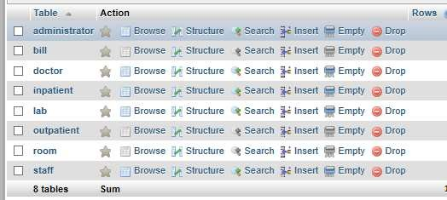

  - Hospital DBMS SQL Server Database Schema Diagram
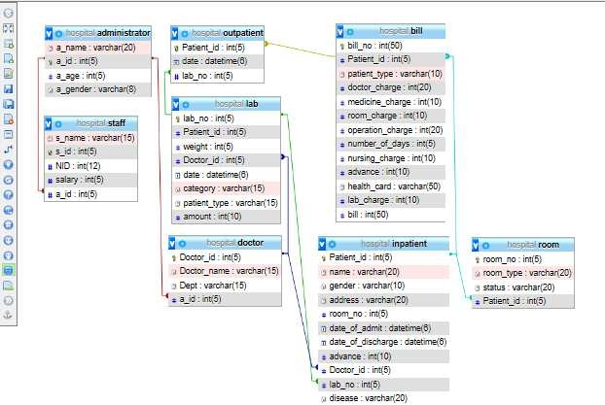

Insert data into all Tables:
Now, we can use insert statement for
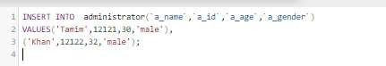

Table:
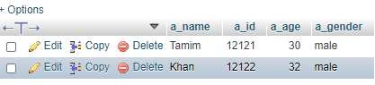
  - For doctor table:
The statement below enters 2 records or rows into doctor table:
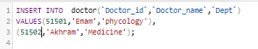
Table:
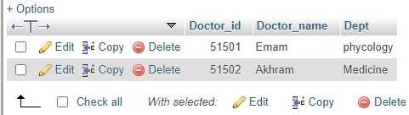
  - For lab Table:
The statement below enters 2 records or rows into lab table:
Table:
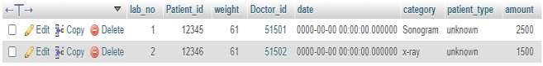

  - For inpatient table:
The statement below enters 2 records or rows into inpatient table:
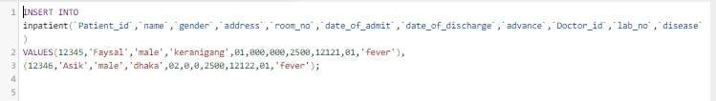
Table:

  - For outpatient table:
The statement below enters 2 records or rows into outpatient table:
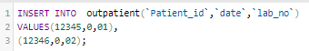
Table:
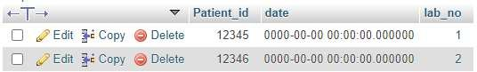
  - For room table:
The statement below enters 2 records or rows into room table:

Table:
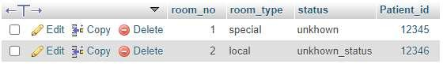
  - For bill Table:
The statement below enters 2 records or rows into bill table:
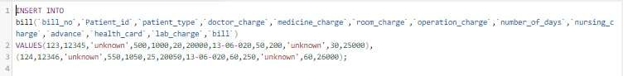
Table:
  - For staff Table:
The statement below enters 2 records or rows into staff table:

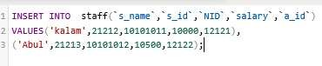
Table:
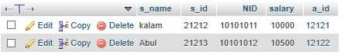
Note: We will store this kind of record or information by using above process.

- Search a patient’s record by his id:
To see patient’s record, we will use select
statement.
I would like to see how much bill, doctor charge, medicine charge, room charge, operation charge, nursing charge are came and how much advance given the first patient's

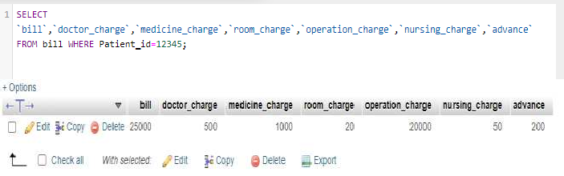

Conclusion

The project Hospital Data Management System (MDBS) is for computerizing the working in a hospital. It takes care of all the requirements of an average hospital and is capable to provide easy and effective storage of information related to patients that come up to the hospital. It generates test reports, provide medicines prescribed to patient and doctor. It also provides billing facility on the basis of patient’s status whether it is an indoor or outdoor patient. The system also provide the facility of backup as per the requirement.

